Nama : Nathanael Hutama Harsono

NRP : 07211940000044

Tanggal : 31/3/2020

**1. Hasil :**

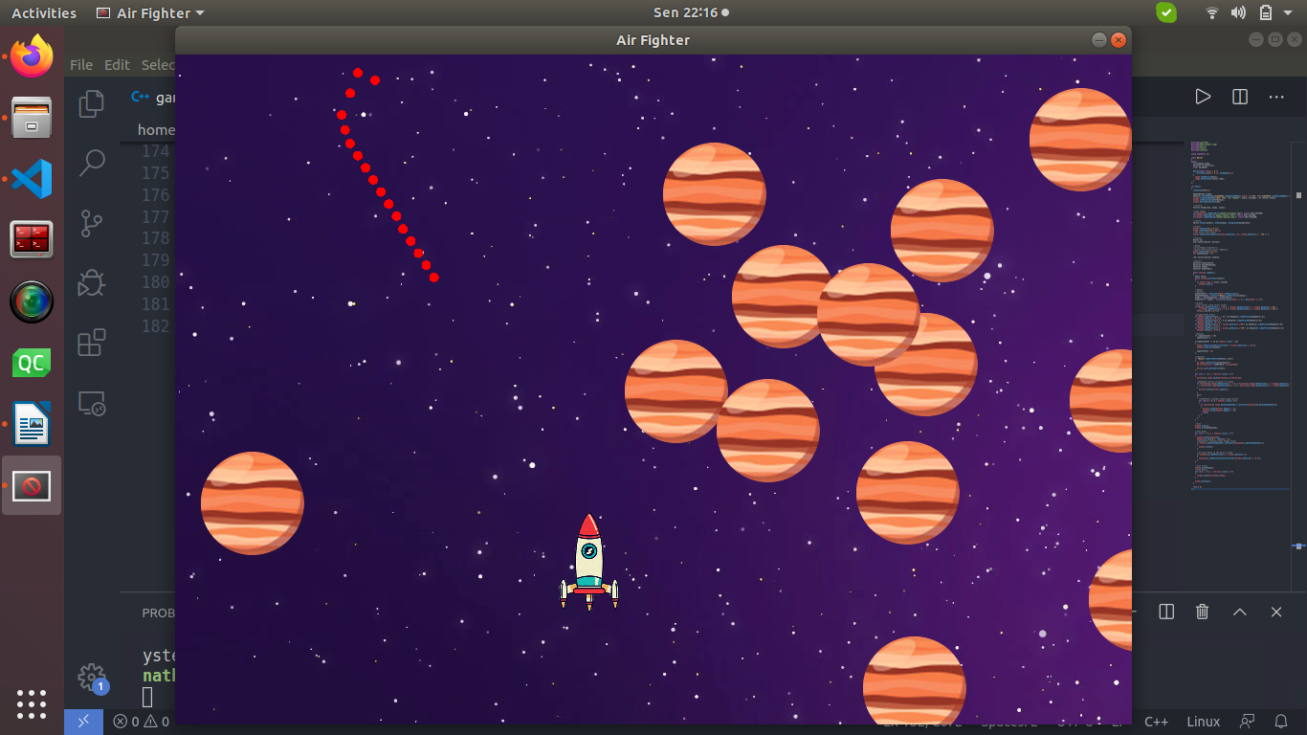

**2. Program :**

#include<iostream>

#include<SFML/Graphics.hpp>

#include<math.h>

#include<vector>

#include<cstdlib>

using namespace sf;

class Bullet

{

public:

CircleShape shape;

Vector2f currVelocity;

float maxSpeed;

Bullet(float radius = 5.f)

: currVelocity(0.f, 0.f), maxSpeed(15.f)

{

shape.setRadius(radius);

shape.setFillColor(Color::Red);

}

};

int main()

{

srand(time(NULL));

RenderWindow window;

Vector2i centerWindow((VideoMode::getDesktopMode().width / 2)-500, (sf::VideoMode::getDesktopMode().height / 2)-390);

window.create(VideoMode(1000, 700), "Air Fighter", Style::Titlebar | sf::Style::Close);

window.setPosition(centerWindow);

window.setFramerateLimit(60);

//texture

Texture background, enemy, player;

//load images

if(!background.loadFromFile("gambar/wallpaper.png")) return EXIT_FAILURE;

if(!enemy.loadFromFile("gambar/jupiter.png")) return EXIT_FAILURE;

if(!player.loadFromFile("gambar/pesawat.png")) return EXIT_FAILURE;

//sprite

Sprite Player(player), Enemy(enemy), Background(background);

//Player

Player.setScale(0.1f,0.1f);

Player.setOrigin(270.f,50.f);

//set posisi awal Player

Player.setPosition(Vector2f(window.getSize().x/2, window.getSize().y - 100.f) );

//Bullets

Bullet b1;

std::vector<Bullet> bullets;

//Enemy

//CircleShape enemy(40.f);

//Enemy.setFillColor(Color::Magenta);

Enemy.setScale(0.2f,0.2f);

int spawnCounter = 0;

std::vector<Sprite> enemies;

//Vectors

Vector2f playerCenter;

Vector2f mousePosWindow;

Vector2f aimDir;

Vector2f aimDirNorm;

while (window.isOpen())

{

Event event;

while (window.pollEvent(event))

{

if (event.type == Event::Closed)

window.close();

}

//Update

//Vectors

playerCenter = Vector2f(Player.getPosition());

mousePosWindow = Vector2f(Mouse::getPosition(window));

aimDir = mousePosWindow - playerCenter;

aimDirNorm = aimDir / (float)sqrt(pow(aimDir.x, 2) + pow(aimDir.y, 2));

//Player

//agar Player tidak keluar window

if (Player.getPosition().x < 35.f || Player.getPosition().x > window.getSize().x-40.f

|| Player.getPosition().y < 0 || Player.getPosition().y > window.getSize().y-100.f)

{Player.move(0.f,0.f);}

//menggerakkan Player

if (Player.getPosition().x > 35.f && Keyboard::isKeyPressed(Keyboard::A))

{Player.move(-6.f, 0.f);}

if (Player.getPosition().y > 0 && Keyboard::isKeyPressed(Keyboard::W))

{Player.move(0.f, -6.f);}

if (Player.getPosition().x < window.getSize().x-40.f && Keyboard::isKeyPressed(Keyboard::D))

{Player.move(6.f, 0.f);}

if (Player.getPosition().y < window.getSize().y-100.f && Keyboard::isKeyPressed(Keyboard::S))

{Player.move(0.f, 6.f);}

//Enemies

if (spawnCounter < 20)

spawnCounter++;

if(spawnCounter >= 20 && enemies.size() < 20)

{

Enemy.setPosition(Vector2f(rand() % window.getSize().x, 0.f));

enemies.push_back(Enemy);

spawnCounter = 0;

}

//Shooting

if (Mouse::isButtonPressed(Mouse::Left))

{

b1.shape.setPosition(playerCenter);

b1.currVelocity = aimDirNorm * b1.maxSpeed;

bullets.push_back(Bullet(b1));

}

for (int i = 0; i < bullets.size(); i++)

{

bullets[i].shape.move(bullets[i].currVelocity);

//Menghapus peluru yg keluar dr window

if (bullets[i].shape.getPosition().x < 0 || bullets[i].shape.getPosition().x > window.getSize().x

|| bullets[i].shape.getPosition().y < 0 || bullets[i].shape.getPosition().y > window.getSize().y)

{

bullets.erase(bullets.begin());

}

else

{

//Mendeteksi tabrakan Enemy dengan Bullet

for (int k = 0; k < enemies.size(); k++)

{

if (bullets[i].shape.getGlobalBounds().intersects(enemies[k].getGlobalBounds()))

{

bullets.erase(bullets.begin() + i);

enemies.erase(enemies.begin() + k);

break;

}

}

}

}

//Draw

window.clear();

window.draw(Background);

//Draw Enemy

for (int i = 0; i < enemies.size(); i++)

{

window.draw(enemies[i]);

enemies[i].move(0.f, rand()%5 + 1);

//mendeteksi tabrakan Enemy dengan Player

if (Player.getGlobalBounds().intersects(enemies[i].getGlobalBounds()))

{

window.close();

}

//me-reset Enemy yg sdh keluar window

if (enemies[i].getPosition().y > window.getSize().y)

{

enemies[i].setPosition(Vector2f(rand()%window.getSize().x, 0.f));

}

}

//Draw Player

window.draw(Player);

//Draw Bullet

for (int i = 0; i < bullets.size(); i++)

{

window.draw(bullets[i].shape);

}

window.display();

}

return 0;

}